**Conflict in the Colonies**

**Socratic Seminar**

The year 1763 marked the end of the French and Indian War, the final defeat of the French and their Native American allies in America. For America’s British colonists, this was a cause for great celebration and pride in their British identity. Expressions of British patriotism were widespread. But only twelve years later, these same American colonists found themselves locked in a bitter and violent conflict with the mother country that had so recently been the object of their proud respect. So what happened?

**How did the changing relationship between the American colonists and Britain lead to the colonists feeling justified in waging war and declaring independence from Britain?**

Your task is to examine and analyze each of the following documents in preparation to discuss the seminar question above.

1. Document Analysis:

* Do a partial OPVL analysis
  + **Origin** – Identify the who, where, and when. Is this a primary or secondary source?
  + **Purpose** – What the goal of the document, why was it created? (explain, inform, persuade, etc.)
* **Circle** key words or phrases.
* Put an **(*) to emphasize** major points.
* In the margin, **write statements and questions** that show connection between the document and the seminar question.
* The questions listed after each document are to help guide your understanding of the document.

2. After document analysis: Write 5 discussion questions/prompts related to the individual documents or the documents as a whole. These questions will be used to prompt discussion during the seminar.

3. Socratic Seminar Discussion: After the documents have been analyzed, the whole class will discuss the seminar question using the inside-outside circles method. Important guidelines to remember:

* Speak clearly, so everyone can hear
* Listen closely
* Speak without raising hands
* **Refer to the text**
* Talk to each other, not just to the leader
* Ask for clarification, if needed
* Invite and allow others to speak
* Consider all viewpoints and ideas
* USE your own questions to encourage discussion
* You are responsible for the quality of the seminar

**Document 1**

**Source**: Excerpt from the Proclamation of 1763 by King George III on October 7, 1763

“And We do further declare it to be Our Royal Will and Pleasure, for the present as aforesaid, to reserve under our Sovereignty, Protection, and Dominion, for the use of the said Indians, all the Lands and Territories lying to the Westward of the Sources of the Rivers which fall into the Sea from the West. (land west of the Appalachian Mountains)

And We do hereby strictly forbid, on Pain of our Displeasure, all our loving Subjects from making any Purchases or Settlements whatever, or taking Possession of any of the Lands above reserved (west of the Appalachians.)

And. We do further strictly enjoin and require all Persons whatever who have either wilfully or inadvertently seated (settled) themselves upon any Lands within the Countries above described (west of the Appalachians.) …forthwith to remove themselves from such Settlements.”



*Why did King George III ask the Parliament to enact the Proclamation of 1763?

*Why would the Proclamation of 1763 upset the colonists?

**Document 2**

**Source**: “Quartering Act of 1765”, excerpt from an unidentified history textbook.



*What 3 things did the Quartering Act force the colonists to provide for the British soldiers?

*Why were New Yorkers especially angry with the Quartering Act?

**Document 3A**

Source: Pennsylvania Journal and Weekly Advertiser, 31 October 1765

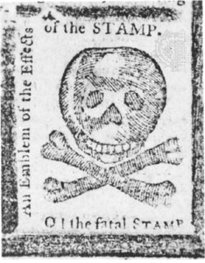

**Note**: American newspapers reacted to the Stamp Act with anger and predictions of the demise of journalism. This image was published the day before the Stamp Act went into effect.

*How did colonists think the Stamp Act would affect colonial economies?

**~~~~~~~~~~~~~~~~~~~~~~~~~~~~~~~~~~~~~~~~~~~~~~~~~~~~~~~~~~~~~~~~~~~~~~~~~~~~~**

**Document 3B**

**Source**: John Dickenson, “Letters from a Farmer,” Editorial published in multiple colonial newspapers, 1767

“There is another late act of Parliament, which appears to me to be unconstitutional, and… Destructive to the liberty of these colonies… The parliament unquestionably possesses a legal authority to regulate the trade of Great Britain and all her colonies. I have looked over every statute (law) relating to these colonies, from their first settlement to this time; and I find every one of them founded on this principle, till the Stamp Act administration… All before, I calculated to regulate trade… The raising of revenue (income)… Was never intended… Never did the British Parliament, (until the passage of the Stamp Act) think of imposing duties in America for the purpose of raising a revenue.

[The Townshend Acts claim the authority] to impose duties on these colonies, not the regulation of trade… But for the single purpose of levying money upon us.”

**Note**: Dickinson was a Pennsylvania political leader who served in the Stamp Act Congress of 1765. Later in his career, he served in the Continental Congress, and later still, in the Constitutional Convention. In the following statement, Dickinson condemned some of the new taxes being imposed by Parliament.

**\***According to Dickinson, what taxes was Parliament justified in imposing on the colonies?

*Why did he object to the Stamp Act and the Townshend Acts?

**Document 4**

**Source**: “The Bloody Massacre” by Paul Revere, March 28, 1770, Editorial published in multiple colonial newspapers

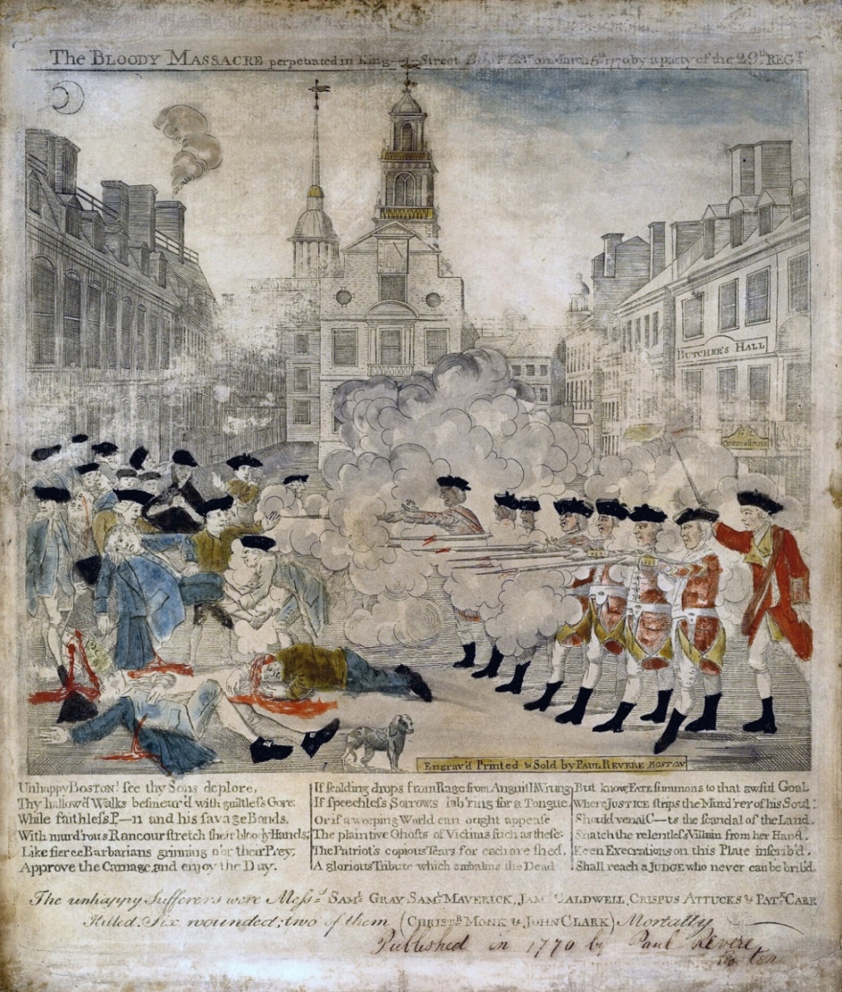

**Note**: British troops had been stationed in Boston since 1768 in order to protect and support crown-appointed colonial officials attempting to enforce Parliamentary legislation. On March 5, 1770, a crowd of Boston boys and men surrounded a number of British soldiers and began taunting and cursing them while they pelted them with snowballs. Order quickly broke down, and the frightened soldiers fired into the crowd. When the shooting ended, several people were dead and more were wounded. This engraving by Paul Revere, a leader of the Boston Sons of Liberty, was sent throughout the colonies in the following weeks to arouse anti-British feelings**.**

*How does the engraving tell a different story from the above description of the Boston massacre?

* Why do you suppose the term "massacre" was used by colonists to describe this event?

**Document 5**

**Source:** George Hewes, An Eyewitness Account of the Boston Tea Party, 1773

“The tea destroyed was contained in three ships, lying near each other at … Griffin's wharf, and were surrounded by armed ships of war…

It was now evening, and I immediately dressed myself in the costume of an Indian, equipped with a small hatchet… and a club, after having painted my face and hands with coal dust in the shop of a blacksmith, I repaired to Griffin's wharf, where the ships lay that contained the tea. When I first appeared in the street after being thus disguised, I fell in with many who were dressed, equipped and painted as I was, and who fell in with me and marched in order to the place of our destination.

When we arrived at the wharf, … they divided us into three parties, for the purpose of boarding the three ships which contained the tea ... as soon as we were on board the ship … [they] ordered me to go to the captain and demand of him the keys to the hatches and a dozen candles. I made the demand accordingly, and the captain promptly replied, and delivered the articles; but requested me at the same time to do no damage to the ship or rigging. We then were ordered by our commander to open the hatches and take out all the chests of tea and throw them overboard, and we immediately proceeded … first cutting and splitting the chests with our tomahawks, so as thoroughly to expose them to the effects of the water.

In about three hours from the time we went on board, we had thus broken and thrown overboard every tea chest to be found in the ship, while those in the other ships were disposing of the tea in the same way, at the same time. We were surrounded by British armed ships, but no attempt was made to resist us.”

**Note**: George Robert Twelve Hewes, a Boston shoemaker, participated in many of the key events of the Revolutionary crisis. Over half a century later, Hewes described his experiences to James Hawkes. When Parliament passed the Tea Act in 1773, colonists refused to allow cargoes of tea to be unloaded. In the evening of December 16, with Hewes leading one group, the colonists dressed in “the costume of a Indian.” They boarded the ships in Boston harbor and dropped the tea overboard. Hewes’ account shed light on how resistance became revolution.

*George Hewes describes the events of the Boston Tea Party on December 16 of 1773. Describe his bias.

*Why were colonists so angry that they boarded ships containing tea in Boston and other colonies?

*What were they instructed to do with the tea? Why do you think they did that?

**Document 6**

**Source**: excerpts from *Common Sense*, Thomas Paine, January 1776.

“Men of passive tempers look somewhat lightly over the offenses of Great Britain, and, still hoping for the best, are apt to call out, "Come, come we shall be friends again for all this". But… Then tell me whether you can hereafter love, honor, and faithfully serve the power that hath carried fire and sword into your land?

… No man was a warmer wisher for a (peaceful settlement) than myself, before the fatal 19th of April 1775 (the battles of Lexington and Concord, Massachusetts, occurred on this day), but the moment the event of that day was made known, I rejected the hardened, sullen-tempered (King of England) for ever.”

**Note**: In response to the Intolerable Acts, the Massachusetts colonial assembly responded by calling for local militias to train for possible hostilities. In April 1775, British Army regulars (soldiers) were sent to capture and destroy rebel military supplies being stored in Concord. The fighting that broke out in Lexington and Concord marked the outbreak of open armed conflict between the Kingdom of Great Britain and the thirteen American colonies.

This popular pamphlet by Paine helped to convince many Americans the conflict with England was beyond peaceful settlement and that independence was America's only course.

* Why was Paine unwilling to be reconciled with Britain?

* Was Paine an objective and unbiased reporter? Explain.

**Document 7**

**Source**: Excerpts from "The Declaration of Independence,” adopted by the Continental Congress on July 4, 1776.

“The history of the present King of Great Britain is a history of repeated injuries and usurpations (unlawful seizures), all having in direct object the establishment of an absolute Tyranny (oppression) over these States.”

“In every stage of these oppressions we have petitioned for redress (remedy, to set right) in the most humble terms; our repeated petitions have been answered only by repeated injury. A Prince whose character is thus marked by every act which may define a tyrant is unfit to be the ruler of a free people.”

* How does this document describe King George?

* From this excerpt of the Declaration of Independence, can it be considered to be an objective and unbiased statement of the American-British conflict? Explain.