New Nation Era Cartoon, c.1799
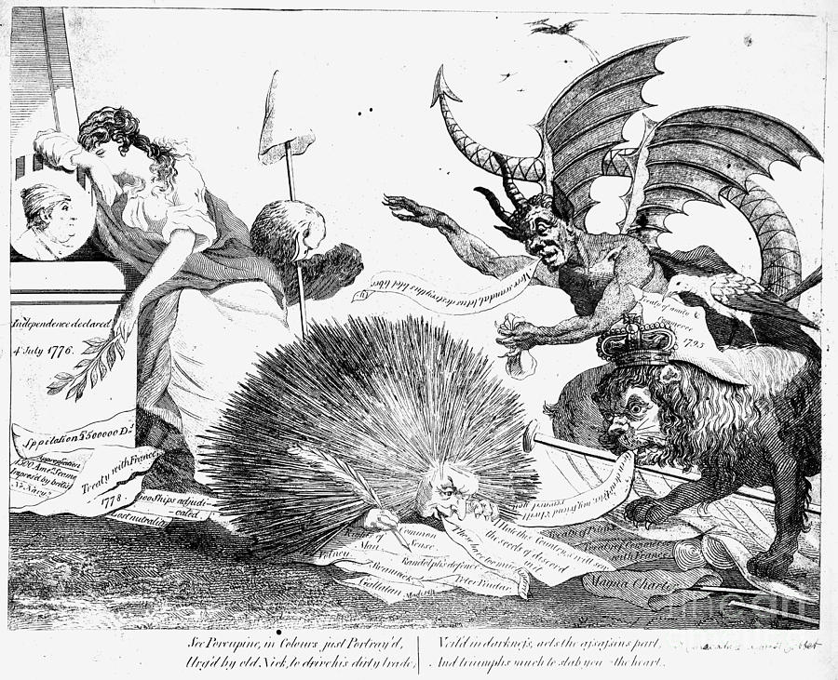
Predict- Discuss with partner and write down:
*Circle images that you think are symbols and label what you think they mean.
*What things in this cartoon do you think are most important? Why?

*Do you think this an anti-Federalist or anti-Republican cartoon? Why?

Question | Answer | Evidence
What is the profession of the Porcupine?

Which country does the lion represent?

Does the cartoonist think the lion is good or bad?

Which country does the lady represent?

Make up your own question and answer it:

Summarize: What is the cartoonist’s opinion about the Federalist and Republican Parties? Give evidence from the cartoon to support your answer.

