Name:
State of the Union 2014 Bingo
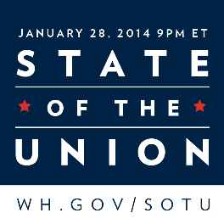
1. Watch President Obama deliver his State of the Union speech live at 9pm on Tuesday, January 28 on any channel that shows the news, or after the fact, watch it online or read a transcript online. (http://www.whitehouse.gov/sotu)
2. When the President says one of the key words or one of the actions is carried out, mark your card.

B | I | N | G | O
First Lady’s Guest Mentioned | Elections | Schools | Supreme Court | Immigration
Natural Resources | Heath Care | Climate Change | Oil | Congress
American Dream | Economy | Free Space | Vice President laughs | College
Guns | Special Interests | Voting | “Let me be clear” | Middle Class
Jobs | Energy | Marriage | Military | Half of the room stands and applauds

Bonus: How many times was the President interrupted by applause?

Parent signature:__________________________________

