Kittens for Adoption
Look at these sweet faces! You know that you want one.
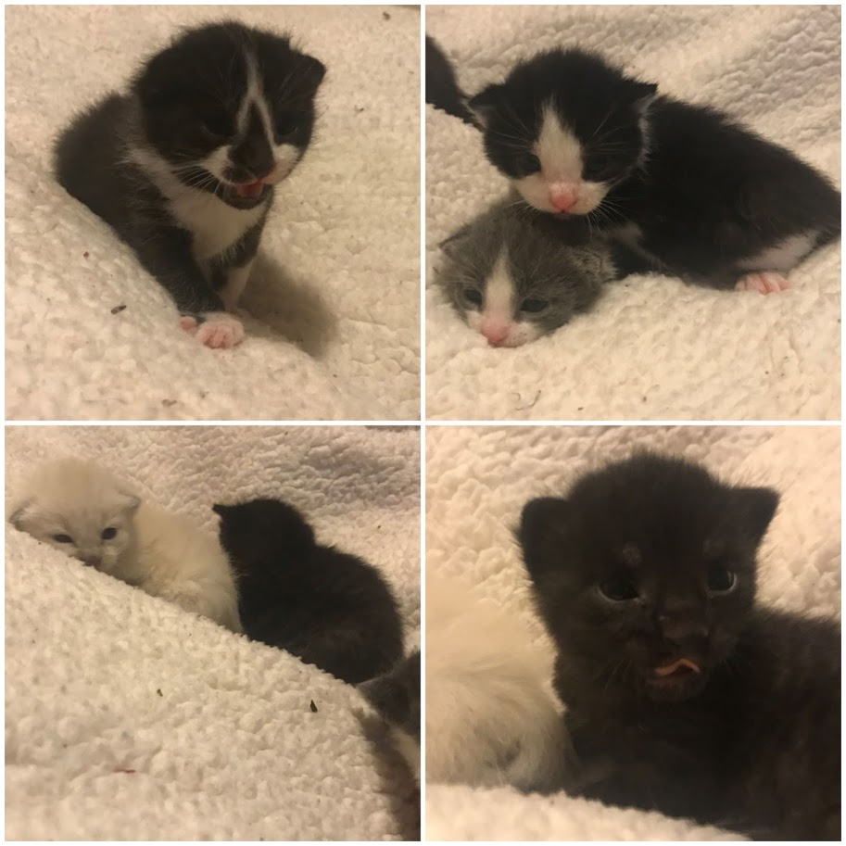
They are 2 weeks old in these photos and will be ready for adoption in mid-June. Free to a good home.
If you are interested, contact Ms. Day for more information.
Jessica_day@scps.k12.fl.us

