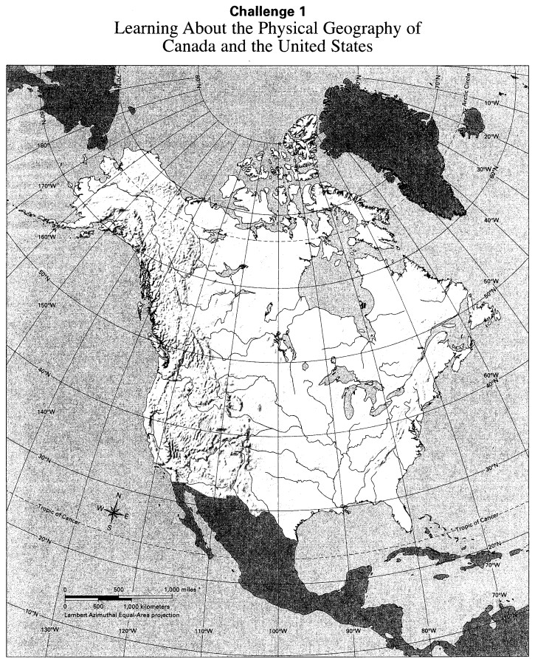
Challenge 2: Learning about the Human Geography of the United States
Directions: Label each state with its name or official abbreviation.
