English Colonies Test Study Guide

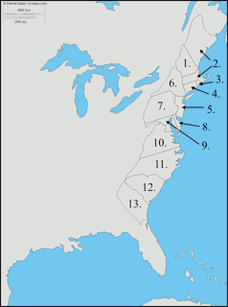
- Identify the locations of the English colonies on the map.
- Identify the bodies of water shown on the map.
- Be able to group the colonies into the three regions:
a. New England
b. Middle
c. Southern

- What was MAIN motivation for settlement of
  - Virginia:
  - the New England Pilgrims and Puritans:

5. What were the problems in Jamestown that almost caused the settlement to fail? What economic activity led to the success of Jamestown?

6. What was the MAIN difference between the ECONOMIC ACTIVITES in the New England, Middle and Southern colonies?

7. Describe the climate and geography of the New England, Middle and Southern colonies?

8. What natural resources led to shipbuilding and shipping to become major economic activities in New England?

9. Describe the founding of Pennsylvania.

10. Describe the founding of Georgia.

11. Florida was a colony of which European country?

12. Describe the Triangular Trade.

13. What is the Middle Passage?

14. Why were slaves imported into the colonies from Africa?

